DATABASE DESIGN DOCUMENTATION

Project Title: | School Management Portal
Prepared By: | Business Analyst
Document Type: | Software Requirements Specification (SRS)
Version: | 1.0
Date: | July 2026

Version | Date | Author(s) | Notes
1.0 | July 2026 | Business Analyst | Original Draft

Table of Contents
S. No | Title | Pg .No
1 | Introduction | 3
2 | Purpose | 3
3 | Scope | 3
4 | Database Overview | 3
5 | Database Architecture | 4
6 | Database Schema | 5
7 | Storage Configuration | 10
8 | Row-Level Security (RLS) | 11
9 | Shared Database Functions | 12
13 | Future Enhancements | 12
14 | Conclusion | 12

1. Introduction
The Database Design Document defines the logical structure of the School ERP Management System database. It describes the database architecture, entities, relationships, constraints, security policies, and storage configuration required to support the application's academic and administrative operations. The document acts as a reference for developers, database administrators, testers, and stakeholders during development and maintenance.
2. Purpose
The purpose of this document is to provide a clear understanding of the database structure used in the School ERP Management System. It documents the database tables, relationships, constraints, access control mechanisms, and storage configuration to ensure consistency, scalability, security, and efficient data management throughout the application.
3. Scope
This document covers the database design for the following modules:
- User Management
- Class Management
- Parent-Student Mapping
- Assignment Management
- Assignment Submission
- Attendance Management
- Examination Management
- Subject Management
- Notifications
- Storage Management
- Database Security (Row-Level Security)

4. Database Overview
The School ERP Management System uses Supa base PostgreSQL, a cloud-based relational database management system. The database securely stores user information, academic records, assignments, attendance, examination data, notifications, and uploaded files. Security is implemented using authentication, Row-Level Security (RLS), and role-based access policies to ensure that users can access only the information relevant to their roles.

5. Database Architecture

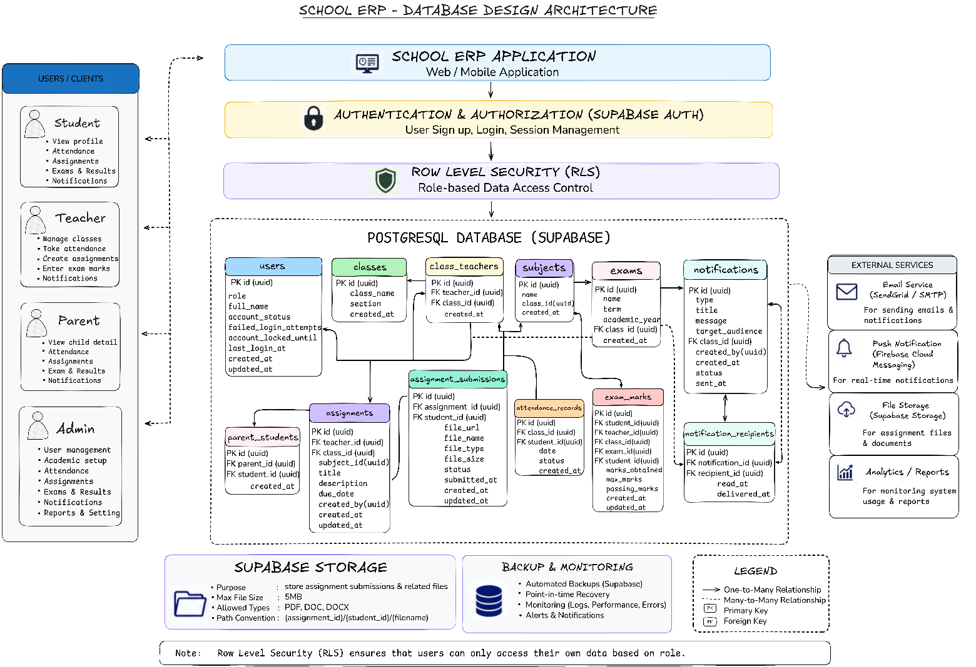
Figure 5.1 Database Architecture of the School ERP Management System

6. Database Schema
6.1 Users
Purpose
Stores user authentication details and profile information for students, teachers, parents, and administrators.
Table Structure
Column | Type | Notes
id | uuid | PK, references auth.users(id)
role | text | admin, teacher, student, parent, principal
full_name | text
account_status | text | active, inactive (default: active)
failed_login_attempts | integer | default 0
account_locked_until | timestamptz | nullable
last_login_at | timestamptz | nullable
created_at | timestamptz
updated_at | timestamptz

6.2 Classes
Purpose
Stores information about classes in the school.
Table Structure
Column | Type | Notes
id | uuid | PK
class_name | varchar(50)
section | varchar(10) | nullable
created_at | timestamptz

6.3 Class Teachers
Purpose
Maps teachers to the classes they are assigned to.
Table Structure
Column | Type | Notes
id | uuid | PK
teacher_id | uuid | FK → users(id)
class_id | uuid | FK → classes(id)
created_at | timestamptz
 |  | unique (teacher_id, class_id)

6.4 Parent Students
Purpose
Maps parents to their respective children for monitoring academic progress.
Table Structure
Column | Type | Notes
id | uuid | PK
parent_id | uuid | FK → users(id)
student_id | uuid | FK → users(id)
created_at | timestamptz
 |  | unique (parent_id, student_id)

6.5 Assignments
Purpose
Stores assignments created by teachers, including due dates and assignment details.
Table Structure
Column | Type | Notes
id | uuid | PK
title | text
description | text
subject | text
class_name | text | legacy field, being phased out
class_id | uuid | FK → classes(id), nullable during transition
due_date | date | must be >= current date
created_by | uuid | FK → users(id)
created_at | timestamptz
updated_at | timestamptz

6.6 Assignment Submissions
Purpose
Stores assignment submissions uploaded by students.
Table Structure
Column | Type | Notes
id | uuid | PK
assignment_id | uuid | FK → assignments(id)
student_id | uuid | FK → users(id)
file_url | text
file_name | text
file_type | text | pdf, doc, docx only
file_size | integer | max 5,242,880 bytes (5MB)
status | text | pending, submitted, late
submitted_at | timestamptz | nullable
created_at | timestamptz
updated_at | timestamptz
 |  | unique (assignment_id, student_id)

6.7 Attendance Records
Purpose
Stores daily attendance records for students.
Table Structure
Column | Type | Notes
id | uuid | PK
class_id | uuid | FK → classes(id)
student_id | uuid | FK → users(id)
date | date
status | varchar(15) | present, absent, late
created_at | timestamptz
 |  | unique (student_id, class_id, date)

6.8 Exams
Purpose
Stores examination schedules and examination information.
Table Structure
Column | Type | Notes
id | uuid | PK
name | text
term | text
academic_year | text
class_id | uuid | FK → classes(id)
created_at | timestamptz

6.9 Subjects
Purpose
Stores the list of academic subjects offered in the school.
Table Structure
Column | Type | Notes
id | uuid | PK
name | text
class_id | uuid | FK → classes(id)
sub_code | text | nullable
created_at | timestamptz

6.10 Exam Marks
Purpose
Stores subject-wise examination marks obtained by students.
Table Structure
Column | Type | Notes
id | uuid | PK
student_id | uuid | FK → users(id)
teacher_id | uuid | FK → users(id)
class_id | uuid | FK → classes(id)
exam_id | uuid | FK → exams(id)
subject_id | uuid | FK → subjects(id)
marks_obtained | numeric | 0 ≤ marks_obtained ≤ max_marks
max_marks | numeric
passing_marks | numeric | 0 ≤ passing_marks ≤ max_marks
created_at | timestamptz
updated_at | timestamptz

6.11 Notifications
Purpose
Stores announcements and notifications generated within the system
Table Structure
Column | Type | Notes
id | uuid | PK
type | text | general, announcement, reminder, alert
title | text | no HTML/script tags allowed
message | text | no HTML/script tags allowed
target_audience | text | students, teachers, parents, all, class
class_id | uuid | FK → classes(id), nullable
created_by | uuid | FK → users(id)
created_at | timestamptz
status | text | draft, sent, archived
sent_at | timestamptz | nullable

6.12 Notification Recipients
Purpose
Stores recipient information for each notification, allowing notifications to be delivered to the appropriate users.
Table Structure
Column | Type | Notes
id | uuid | PK
notification_id | uuid | FK → notifications(id)
recipient_id | uuid | FK → users(id)
read_at | timestamptz | nullable — only column users can self-update (trigger-enforced)
delivered_at | timestamptz
 |  | unique (notification_id, recipient_id)

7. Storage Configuration
Purpose
The School ERP Management System uses Supabase Storage to securely store files uploaded by users. Storage is configured to ensure secure access, controlled file uploads, and organized file management.
Storage Configuration
Item | Configuration
Storage Type | Private Storage
Maximum File Size | 5 MB
Supported File Types | PDF, DOC, DOCX
Storage Path Convention | {assignment_id}/{student_id}/filename

Description
The storage bucket is configured as a private bucket, ensuring that uploaded files are accessible only to authorized users. Assignment submission files are organized using the path convention {assignment_id}/{student_id}/filename, making file retrieval efficient while maintaining a structured storage hierarchy. File uploads are restricted to PDF, DOC, and DOCX formats with a maximum size of 5 MB.

8. Row-Level Security (RLS) Access Summary
Purpose
Row-Level Security (RLS) is implemented to ensure that users can access only the data they are authorized to view or manage based on their assigned role. This enhances data security and protects sensitive academic and administrative information.
RLS Access Summary
Teacher
Access is limited to assigned classes through the class_teachers table. Teachers can create and manage assignments, examination marks, and notifications that they own. Deletion of records is restricted to Admin users.

Student
Students can view only their own attendance records, examination marks, assignment submissions, and notifications. They are permitted to create and submit their own assignment submissions
Parent
Parents have read-only access to the academic information of their linked children through the parent_students table. Parents do not have permission to create, update, or delete any records.
Admin
Administrators have full access to all database tables and system resources, including the ability to create, update, and delete records across all modules.
Description
Role-Based Access Control is enforced using Supabase Row-Level Security policies. These policies ensure that every authenticated user can perform only the operations permitted for their assigned role while protecting sensitive data from unauthorized access.

9. Shared Database Functions
Purpose
Shared database functions provide reusable logic that is utilized across multiple modules. These functions help maintain consistency, simplify permission checks, and reduce duplicate implementations within the database.
Shared Functions
Function Name | Description
is_admin_equivalent() | Returns true when the authenticated user's role is Admin. This function is used to simplify authorization checks and enforce administrative access across database operations.

Description
The is_admin_equivalent() function is referenced by Row-Level Security policies to verify whether the current user has administrator-level privileges. By centralizing this logic into a shared function, the database maintains consistent authorization behavior and improves maintainability.

10. Future Enhancements
The current database design has been developed to support future expansion with minimal structural changes. As the School ERP Management System evolves, additional modules, enhanced reporting capabilities, and performance optimizations can be incorporated while preserving data integrity and scalability.

11. Conclusion
The Database Design Document provides a comprehensive overview of the database architecture, schema, storage configuration, security policies, and shared functions used by the School ERP Management System. The database has been designed to ensure data integrity, secure access, scalability, and efficient management of academic and administrative information. This document serves as a reference for development, testing, deployment, and future maintenance activities.

